REACT JS
#React Kya Nahi Hai??
1.Not a language
2.Not a framework
3.Not a Technology
#Kya Hai?
1.Ek library Hai
2.Facebook ne Banayan 2013 mai
3.Open source mai pahali baar hui 2015 mai
4.Can change real time notifications/reactions without refresh
5.Js library to maintain front-end efficiently
#REAL DOM (Document Object Model)
1.Jab aap ek change karte ho web mai tab aapka poora web repaint/re-render hota hai issse kahate hai DOM re-render.
2.Mtlb jaha change nahi hua hai wo bhi repaint Yanai re-render hoti hai.
3.Jo ki ek long and inefficient work hua.
4.Ye web ko slow down kar deta hai
#VIRTUAL DOM
1.It is exact copy of real dom one change is only i.e
2.Jaha jis component mai changes hui hai sirf wahi part re-paint/re-render karta hai.

#Advantage Of React
1.Increase UI
2.Increase re-usability of code
3.Very Very Very less page reloads
4.Efficient extreme use of reusable code
5.Lightweight

#Set Up
A. Requirements
1.Vs code (Extension tabnine , prettier, material icon)
2.Node js
3.Vite
‘It offers raw react
‘check first ki node js download hua ya nahi by npm-V
‘go to website
‘copy npm link & paste to cmd(win+R)
‘write project name
‘select framework à react
‘select a variant à js
‘after that we have to run 2 command in cmd
‘cd <file_name> ……..npm install
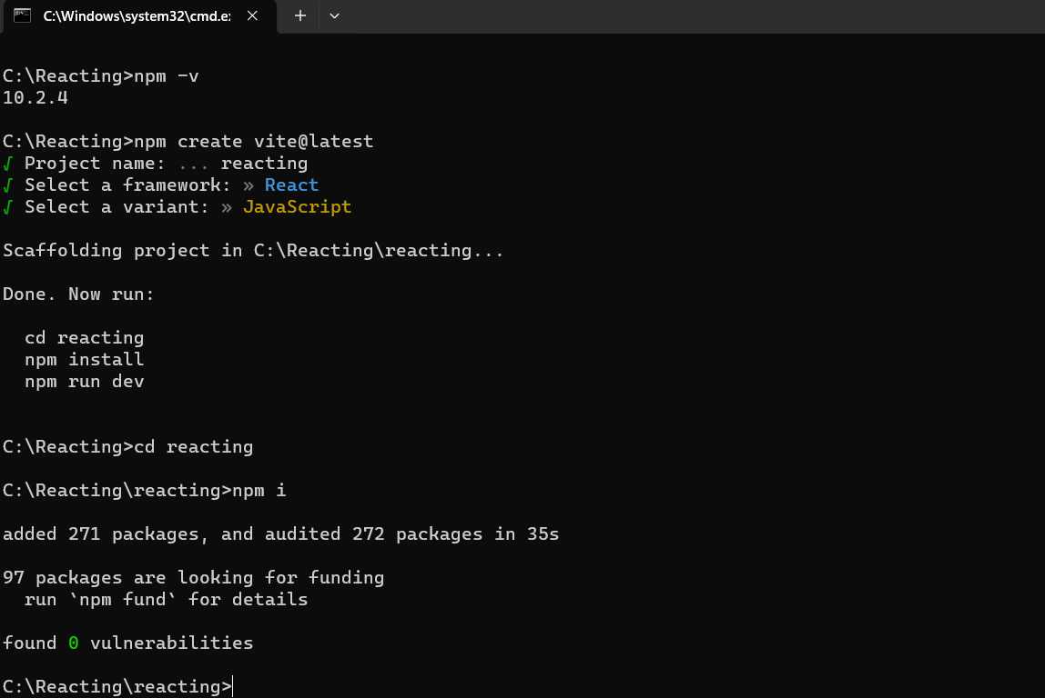
‘ now open vs code in that folder
#What’s the content in that folder?
1.node_modules à ye wo cheeze hai jo behind the scene react ko ch
2.public-vite à all static assests
3.src à main material where we work
4.jsx à it is actually a very similar looking structure like html.
It’s a html with super powers.
Ex. <h1>2+3</h1> à in html only print this
- In react it gives 5 by solving it
- It actually due to React.createElement
- 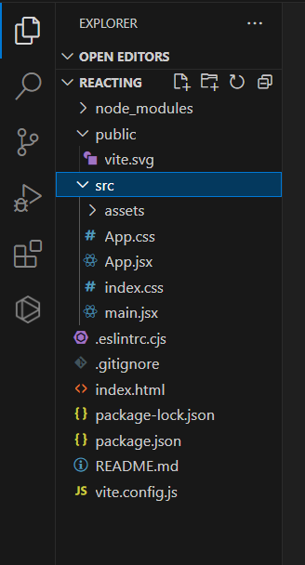
- Delete file App.css and content of file app.jsx
5. App.jsx à place where u write react code
6. main.jsx à ye App.jsx ko run karta hai by taking its data in it body
#Component à ek code jo ham aage use kar sakte hai
It works to return jsx
#Creating first component!
- App.jsx à write rfce to write functional components
- Open terminal and write npm run dev
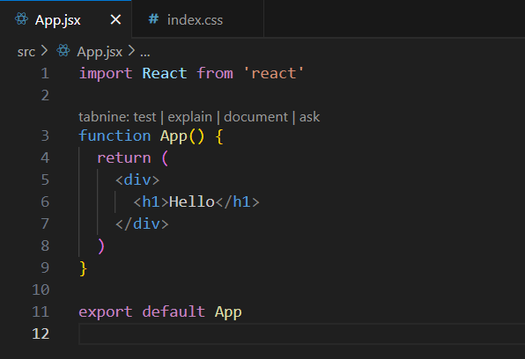
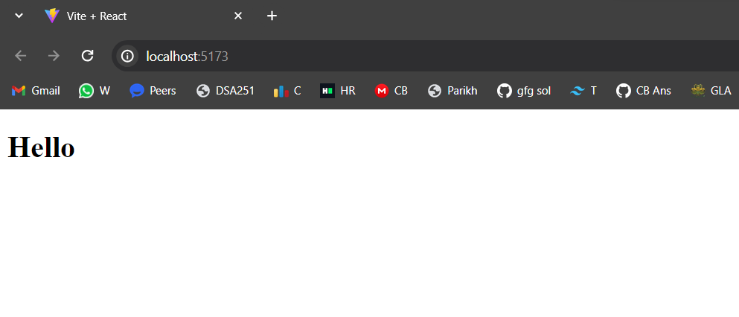
4.Actually data app mai hota hai jo ki main apne body mai le ata hai jo ki phir render kar deta hai
#Creating Second Coponents and joining them with App
1.Create folder in src called Components
2.Make file with first letter capital Navbar.jsx
3.Now for linking import Navbar in App.jsx
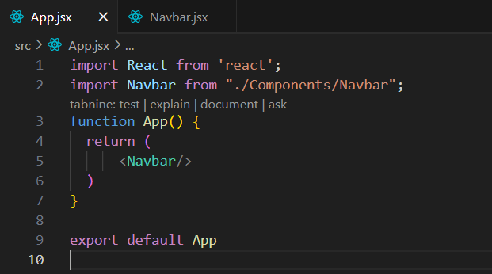
#Returning jsx
1.You can’t return more than one thing with function.
2.Thus you cant return it using <></> or by <div></div>
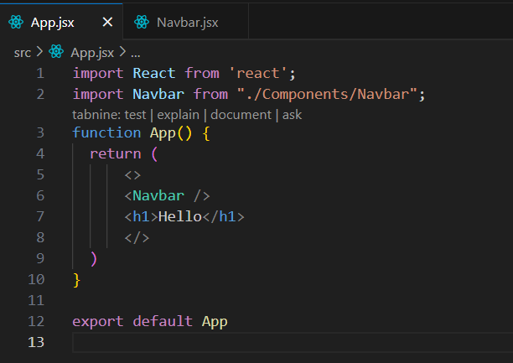

TAILWIND CSS
#Importing / Linking tailwind in .html file
1.Go to browser and open tailwind
2.Go to docs
3.Click on play CDN
4. Now copy script tag line and paste it to .html file
#Tailwind Importance
- Mtlb ki css hath se nahi likhni hai sirf class lagani hai
- Sabse pahale css mobile phone ke liye likhna hai
- Responses ke liye breakpoints target karne hai
- Go to its web and search for each and everything you need
- Firstly we have to make for phone ,for tablet,PC , large screen and for extra large screen.
#Notes
1.Full screen w-full h-screen
2.For padding px-<no> py-<no>
3.For center mx-auto
4.For container container (by default left align)
5.For align items items-center
6.For text size text-xs, text-s,text-l,text-xl
7.For space b|w justify-b|w
8.For gap between gap-<no>
#For Icons
1.Go for remixicon.com
2.Click on github icon link
3.Copy CDN & paste to .html
4.Now choose your icon and copy class name

#Creating Card Component
1.Create a file Card.jsx in Components folder
2.Now write basic code
3.Import that in App.jsx
4. 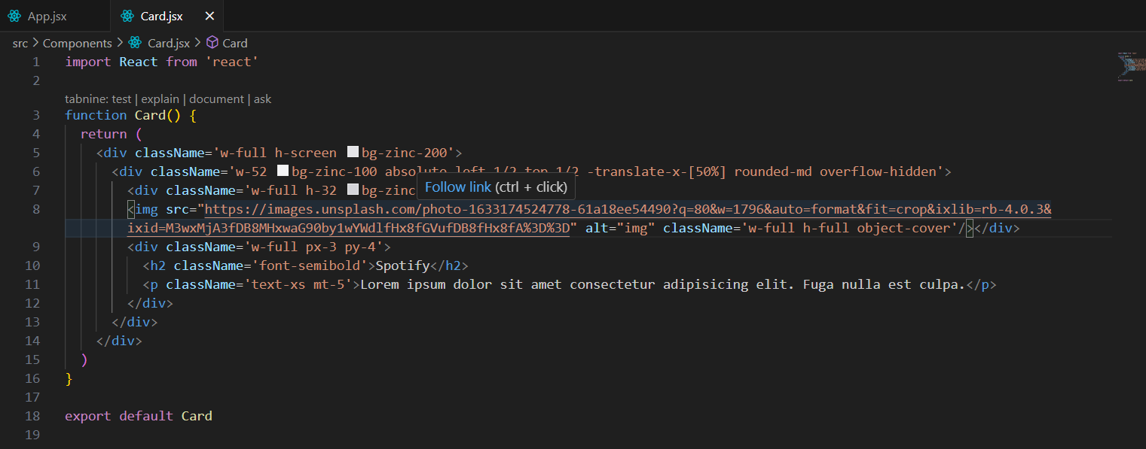
5. 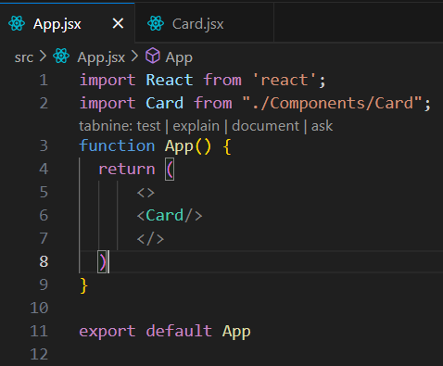
6. 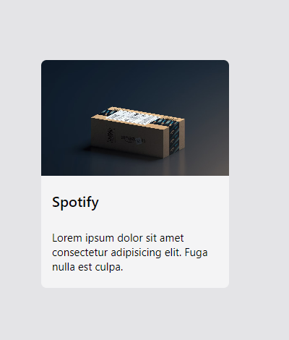
#Linking Tailwind CSS
1.Go to tailwind css on browser
2.Go to docs framework guide Vite
3.Copy the project link and paste it into terminal of Vs
4.Again copy and paste it into terminal.
5.This will install :
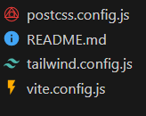
6.Copy and paste config your template paths to tailwind.config.js
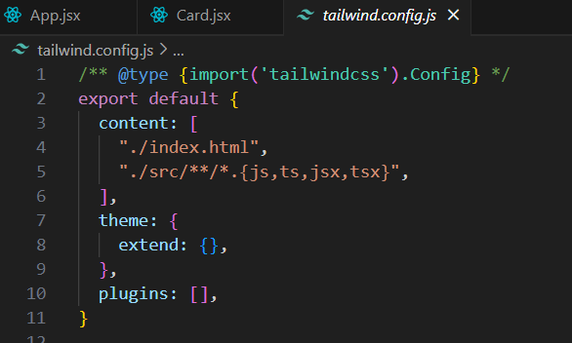
7. Add the tailwind directives to index.css
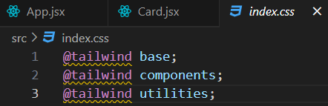
#NoteFor moving one screen to other use alt+tab
#map()
1.In normal JS we use for-each but in react we use map()
2.Because for-each doesn’t return anything
3.Thus map() return its specific value
4.In map() we use arrow function which returns the
target value
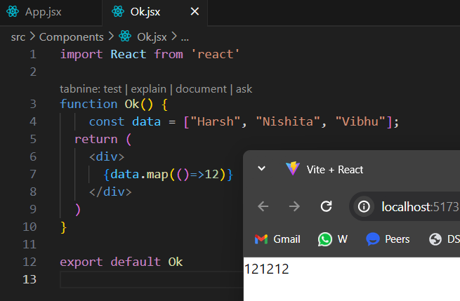
5.Through .map() we can iterate to every element.
6.map() always accept a function thus we are providing
arrow function to it.

#Key Proping
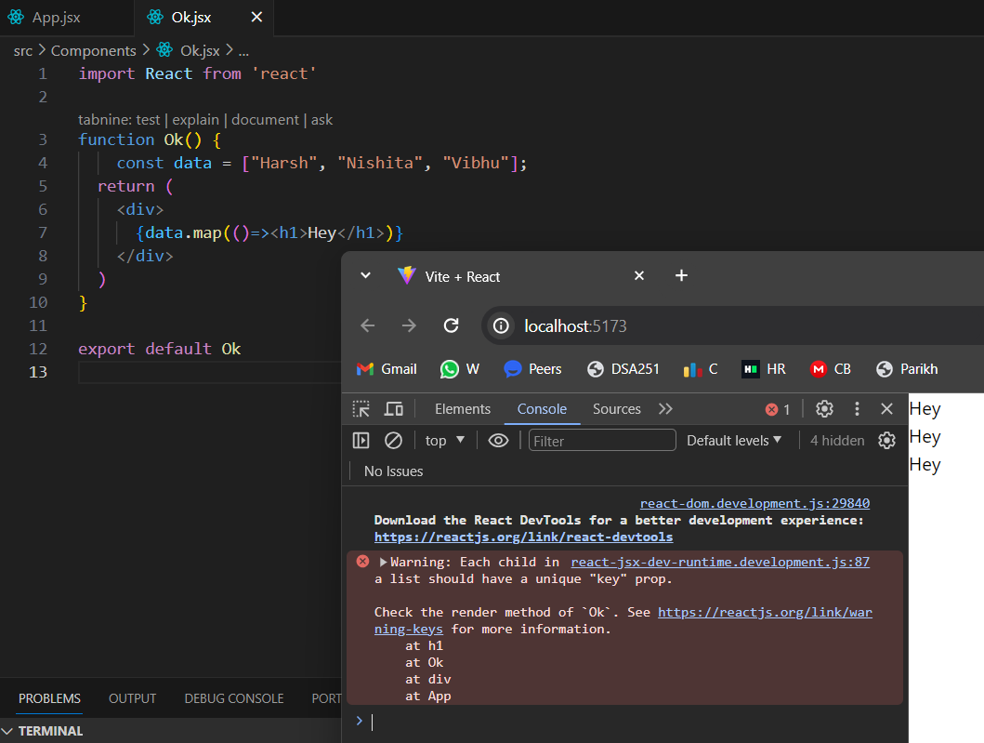
This error comes because here each Hey acts as a different component so virtual DOM wants to say that why it all seems to same ……it should have proper key.
1.So react js wants to pass some key to handle this error.
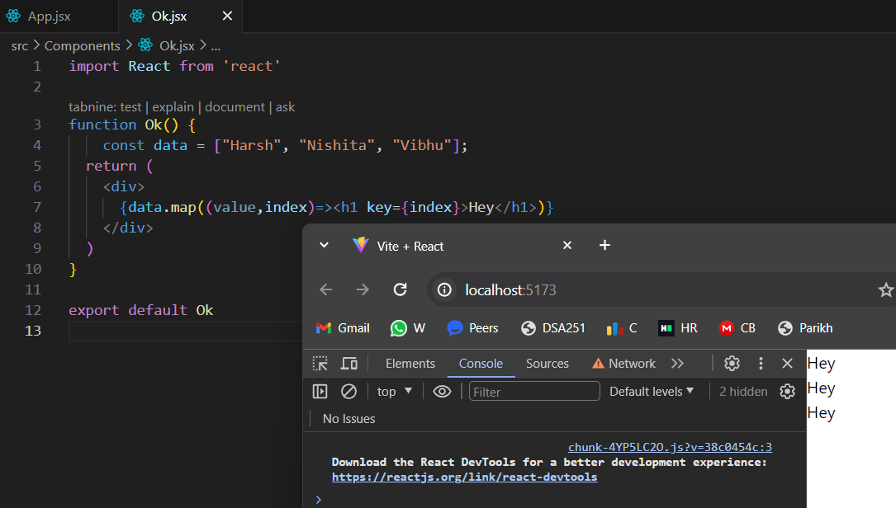

#Iterating Over An Array
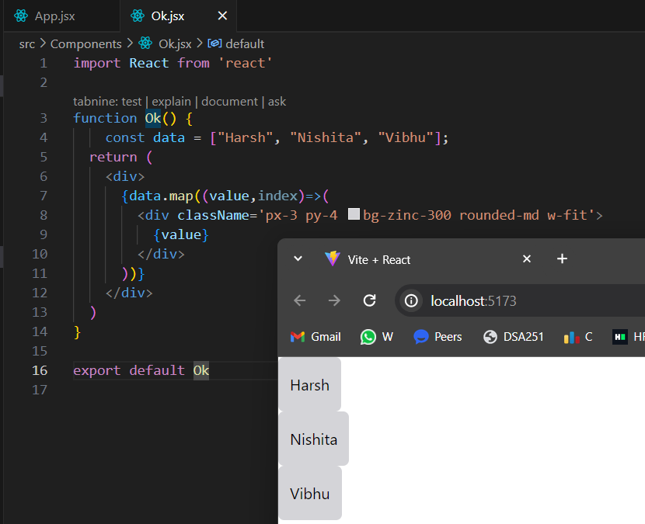
#Showing Cards With Data
1.Trick is to for beginners first aap static one card bana lo then array banana usme data dalna and change kar dena calling ke time.
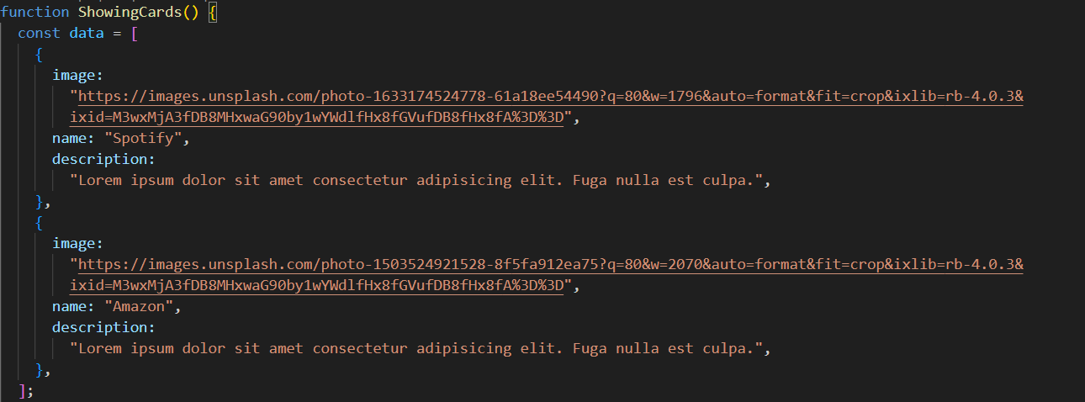
#NOTE :- to make code prettier press shift+Alt+F
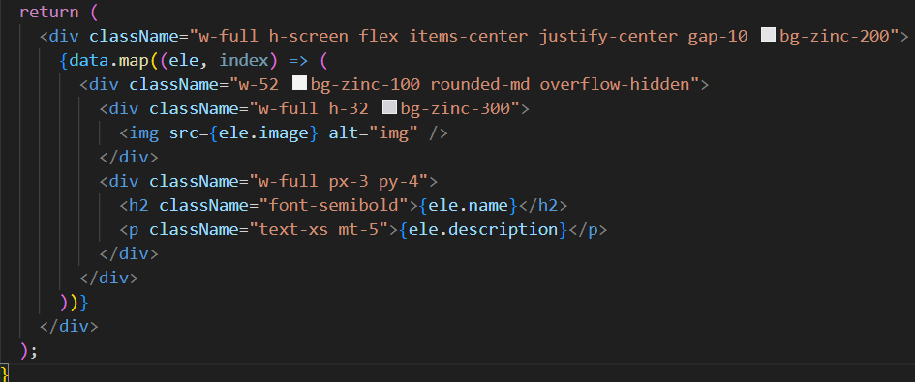
#Fragments
1.Bina extra div banaye ya parent element banaye aap cheezo ko wrap kar sakte ho using this.
2. <> …….</>
3.Used to couple up many code.
#Conditional Rendering
1.For elements printing we normally use ternary
operator in {}
2.For color or text changes we cant put directly {} in
className but we have to make {`…`}
3.Now we have to write it in ${}
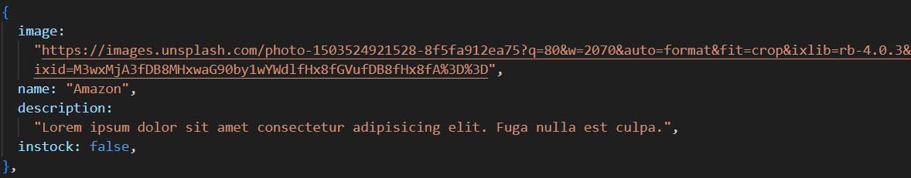
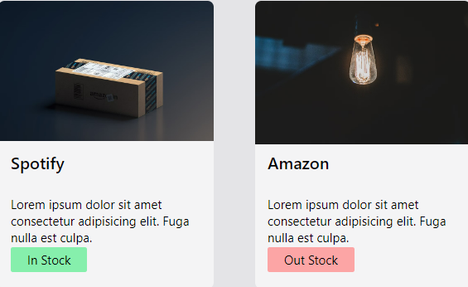
#Handling events
1.Download bagera and upload bagera handling mai aa
2.Inn sabko handle karne ke liye specific function diye
hai jinme function pass karte hai…ex.
onMouseOver,onClick,onHover,etc.
3.
4. 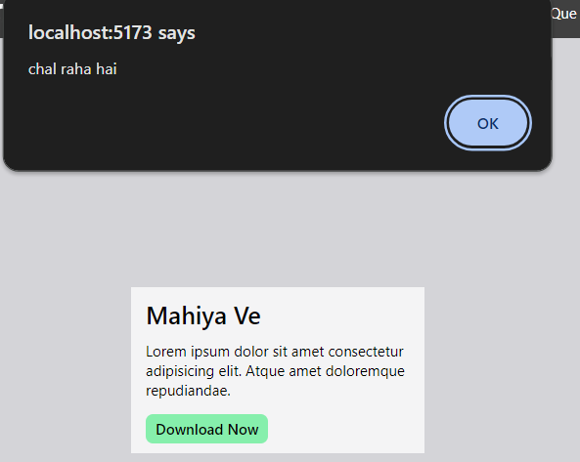
5. 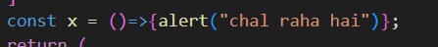
We can also assign it to some variable and simply put it
In onClick={x}.
#State Management useState() hook
1.state ek data hota hai react is data ka khayal rakhta hai jab bhi ye data change hota hai react page ko update karta hai
2.state koi bhi data ho sakta hai jesse ki score = 0
3. useState(0)
4.maan lete hai apka game mai score by default 0 se shuru hota hai and future mai wo score badegha by 10 aur aapko page par show bhi karna hai jab score badhe,uss case mai aapka score variable ek stat mai rakhna jaruri hai
5.Kyunki react sirf use change karta hai jo state mai hota hai
6.Aap useState() mai kkuch bhi pass kar sakte ho like: no,array,Boolean,etc
7. 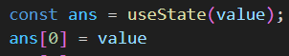
8.Jab bhi ham useState() ko ek variable mai store karate hai tab wo as a array sotre karta hai , jiska 0th index wahi value hogi jo useState() mai pass hoga
9.And 1st index mai ek function hoga jo value ko change karta hai
10.So for easy understanding we can do:
11. 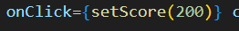
We can’t do shit like this, by passing value directly as,
When compiler read code then it directly call that function, without clicking the button.
12.To resolve that we can do 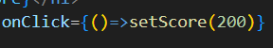
Now f() can’t be called directly.
#Intermediate useState()
1.For printing value by increasing one by one we use
Prev the gives us score which we then increase
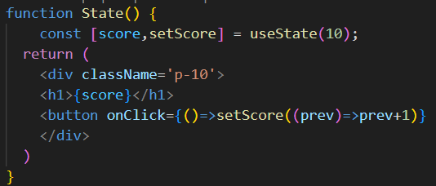
2. 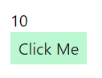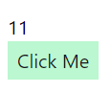
#Advanced useState()
1.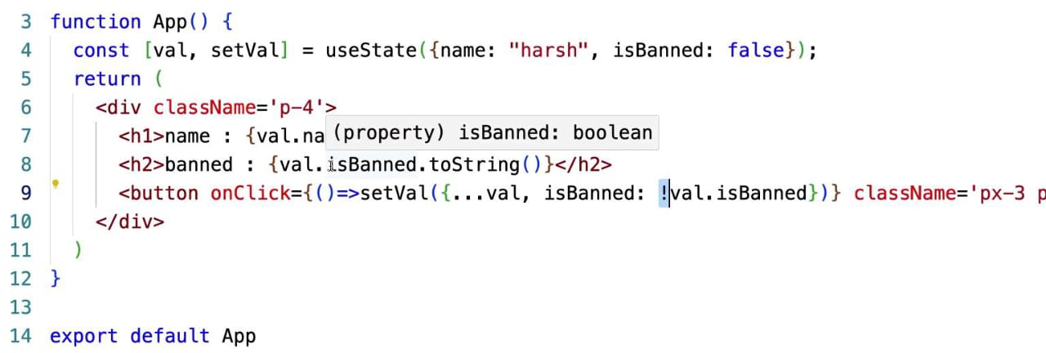
2.Here we use spread operator (…) to pass all value of
object
#Mastering useState()
- 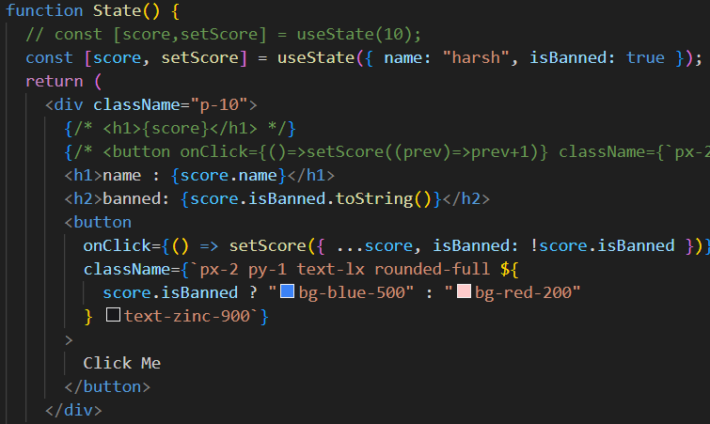
- Jab bhi ham ek object pass karte hai toh use call karne ke liye score.value likhna hoga
- Ham Boolean value ko directly print nahi karte thus hamko use String mai badalana hoga using .toString()
# Mastering useState() II
1.Isme hame useState() ki help se value add karna hai hamare object mai
2.useState() state ko turant update nahi karta
3.wo state ko update karta apne hisaab se function completion ke baad to fix performance
4. 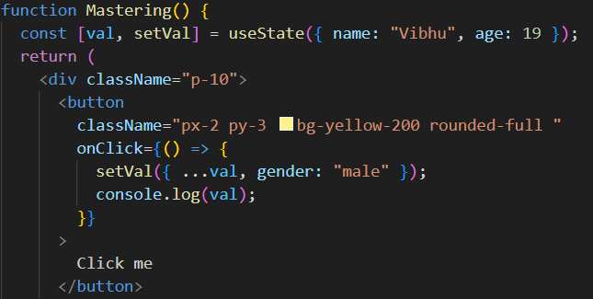
5.useState update state only after completion of whole case.
6.Thus pahale click karne par koi value update nahi hogi agale click par hogi update.
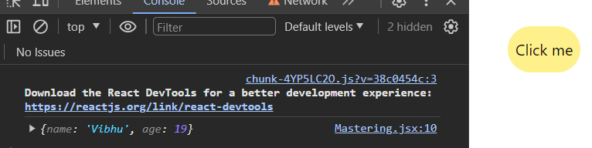
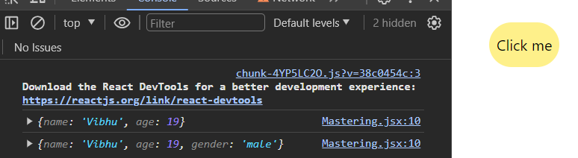
7.technically we can say update state asynchronously.
#useState() Arrays .map, filter
1.For iterating the array elements we can use .map
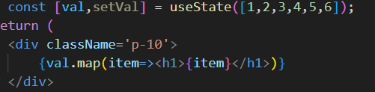
2. 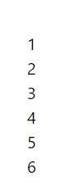
3.Now hame one-by-one ye no delete karne hai so for
that we simply use .filter which returns an array.
- 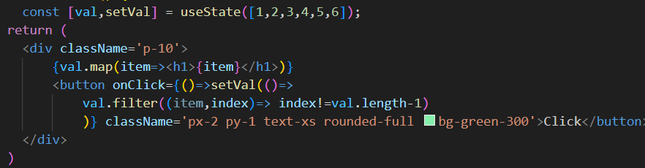
- 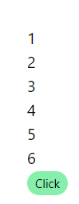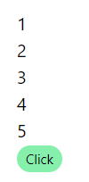

#useState() Arrays II
- 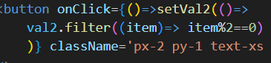
- 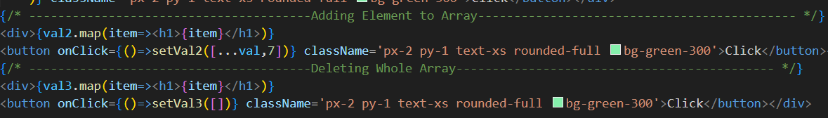
- PLAYING WITH AN ARRAY OF OBJECTS
- 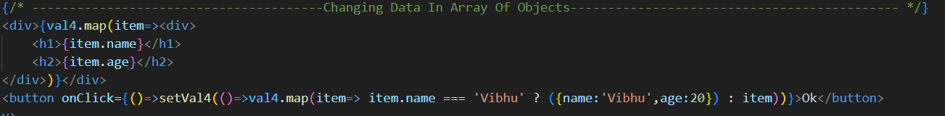
- 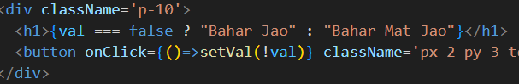
- This not a better way to write this.
- 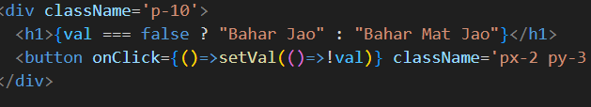
#Making Something
1.
#NOTE: We can use React Icons also by installing its react.icon package by 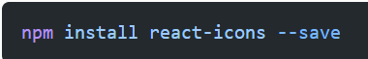
Then copy whatever icon you want and paste import line in ur top code.
#
#
#
#
#
#

